Cloning repository from github



1,clone a repository

2, if it doesn’t have any files inside you don’t need to do pull

3, open a folder in your local and clone the repo

4, open the cloned repository in terminal and open it vs code as well

5, make some changes

6, add, comit the changes and then push it to the remote repo

Note. You don’t need to mention the remote location when you push from local since it knows who the origin master is

Connecting local to remote

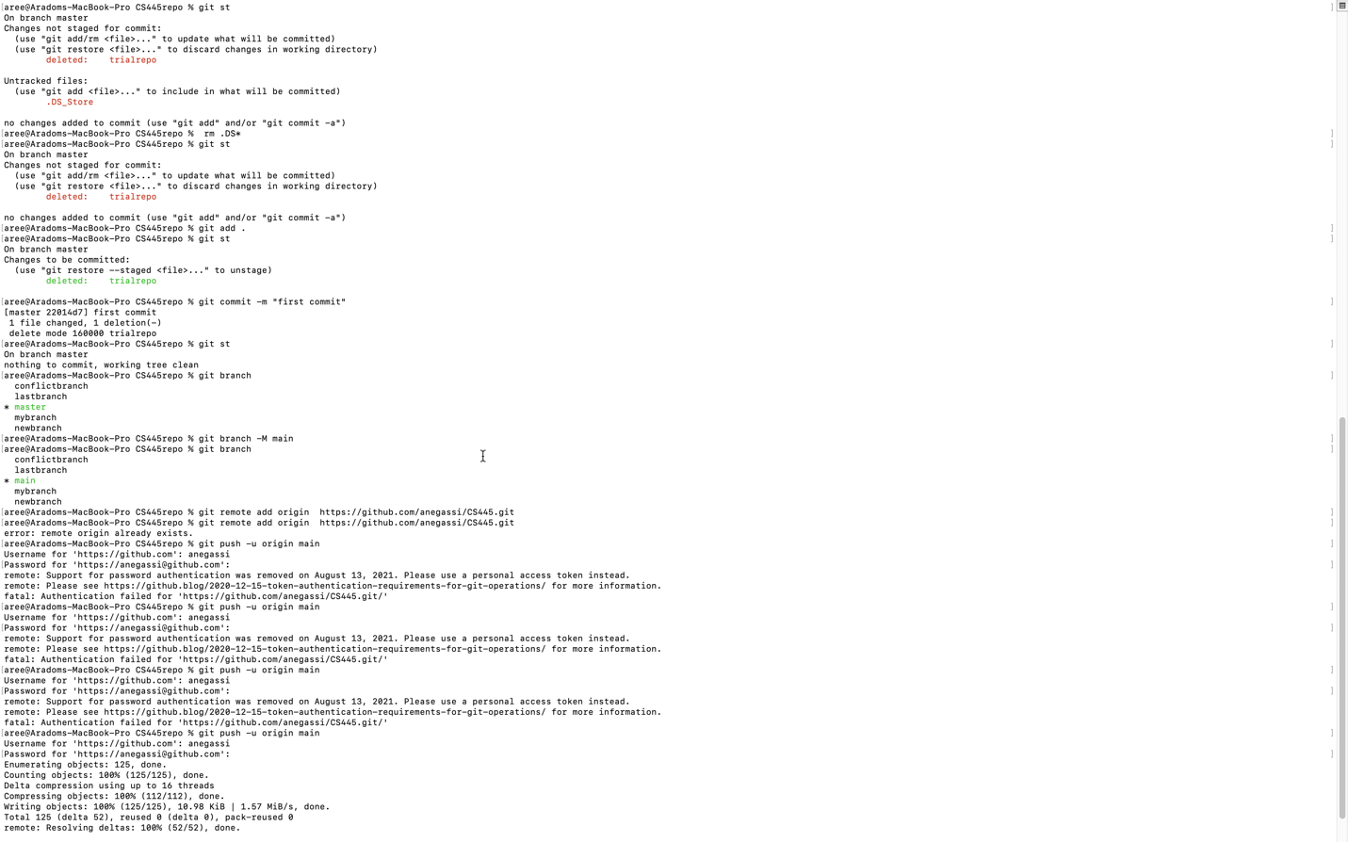

1, create your local repository

2, create a remote repository with out any files and then follow the instruction there to sync the local main to the remote main

Fetch and merge from Remote repo(pull)

1, make a file in remote and fetch it in local

2, git doesn’t automatically recognize changes in the remote repo until you say fetch and your local repo will be behind the main in remote so you have to make them synchronize by merging or you can do pull from origin/main that will fetch and merge at the same time







Git Push (from local to remote)





How to Fork from a repository and send pull request

1, fork a repo from an upstream repo

2, clone a repo, open the cloned repo in terminal

3, make a topic branch and checkout to it

4, open vs code and make some changes and add and commit

5, merge the topic branch with the main

6 and push to the remote repo(forked)

7 send a pull request to the upstream repo

